|  |  |
| --- | --- |
|  |  |
| WORKSHOP 3 |  |
|  |  |
|  | 26/06/20Ingenieria de Software 2 |
|  | Parra Tarira EfrenPorro Loor RenzoDurango DavidAlvarez Alvarado Edmundo |

|  |  |  |  |
| --- | --- | --- | --- |
|  |  |  |  |

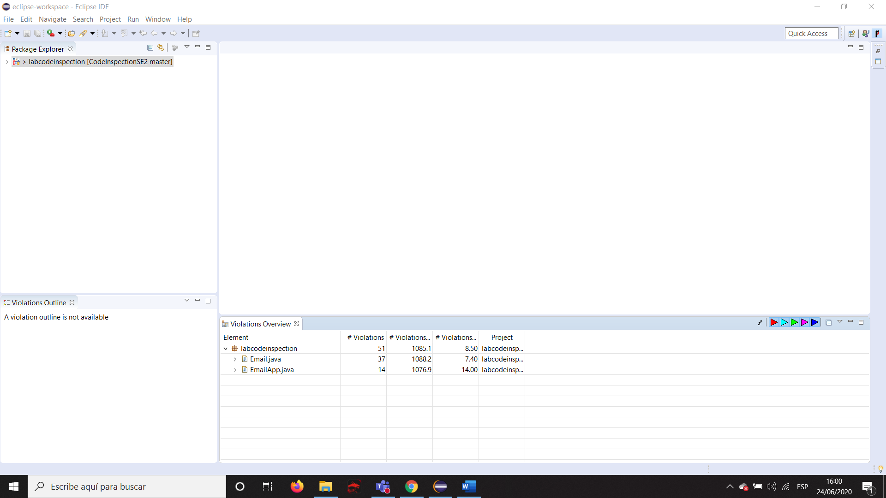

After checked with PMD

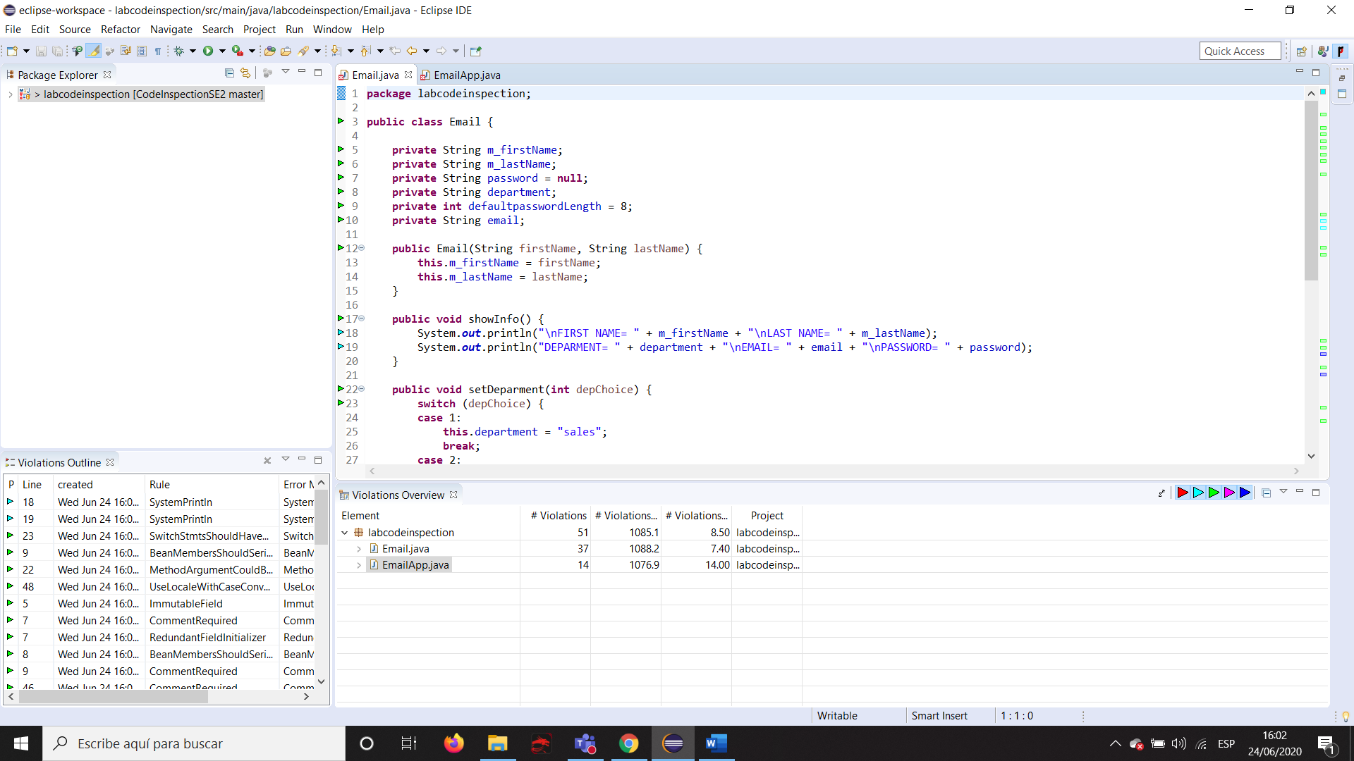

Code checked with PMD

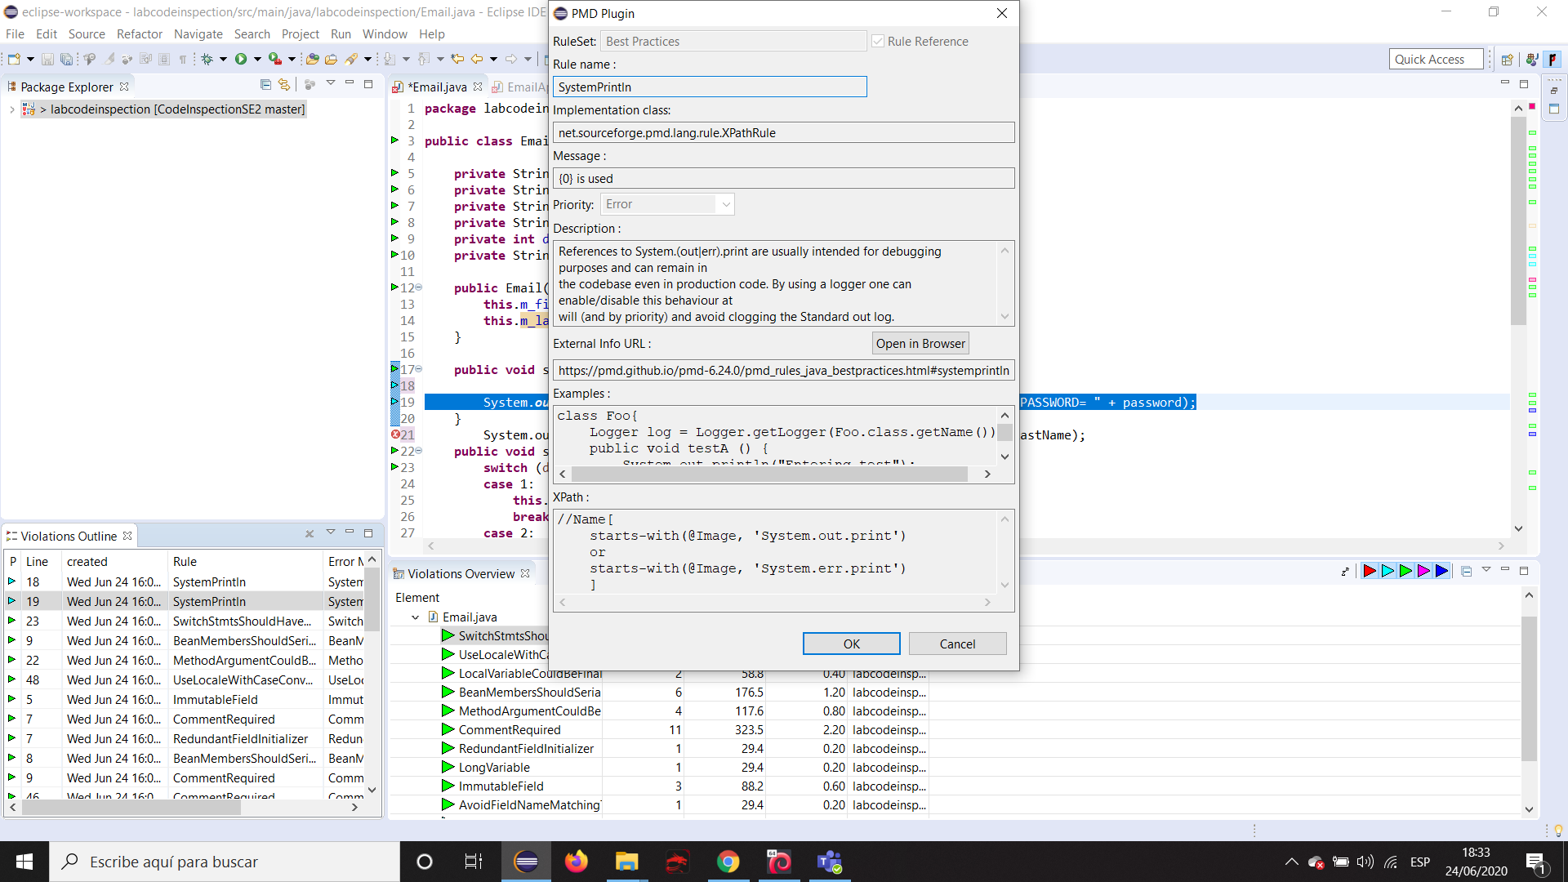

Details of a critical violation

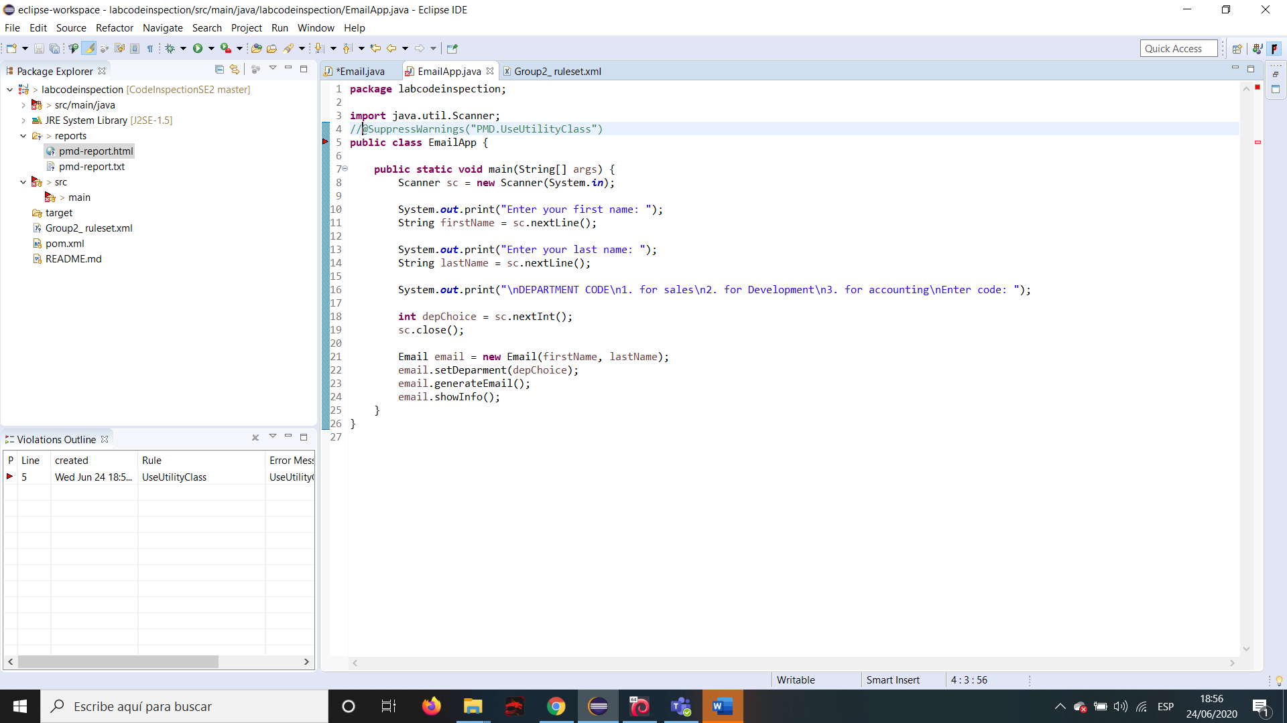

Before suppress warning

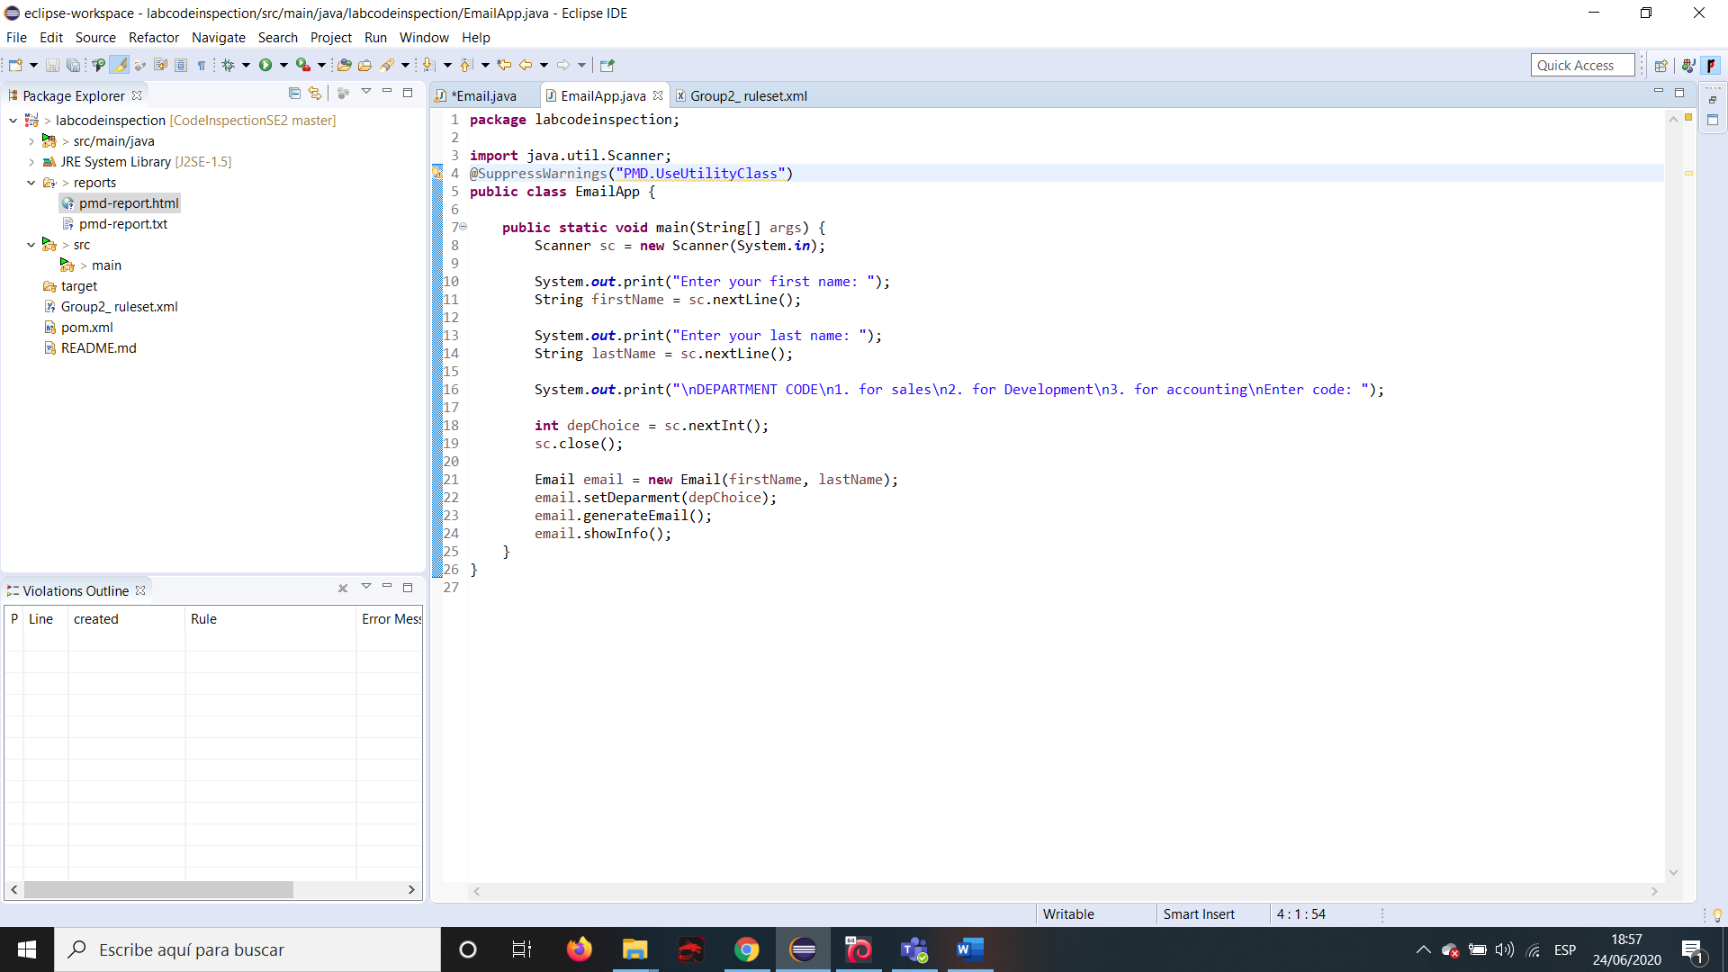

After Suppress Warning

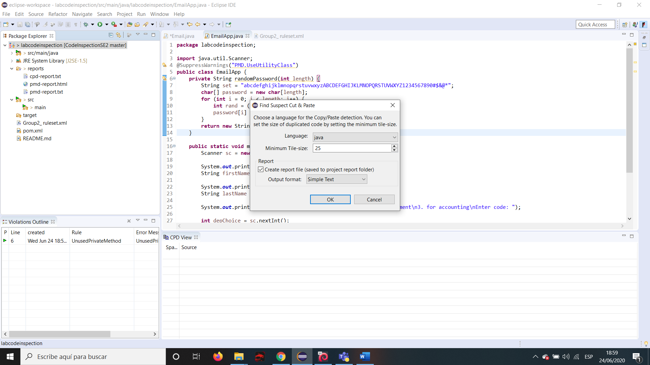

Find a Cut and paste suspect

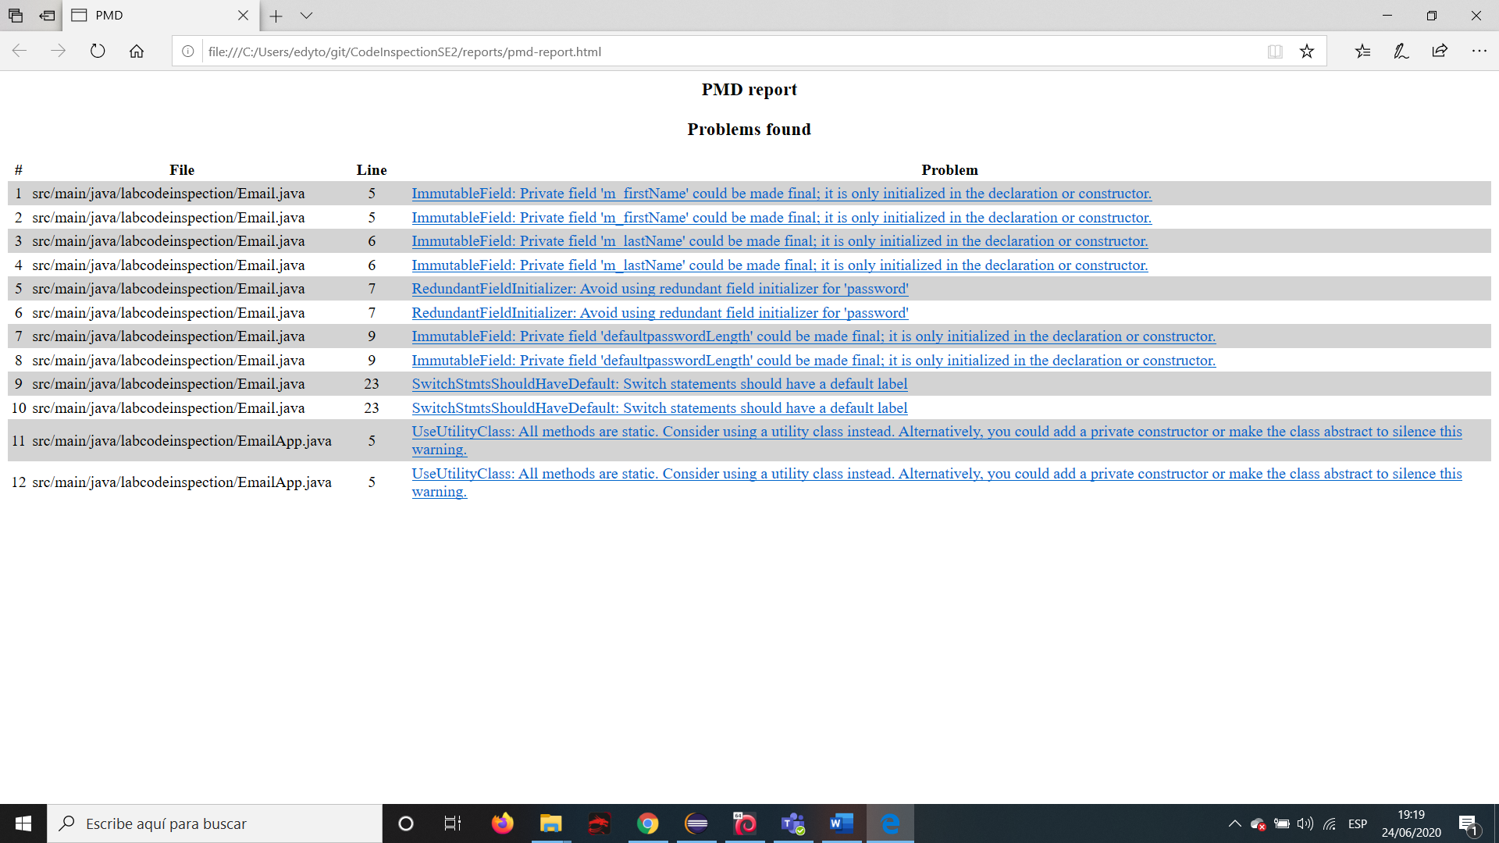

PMD Report

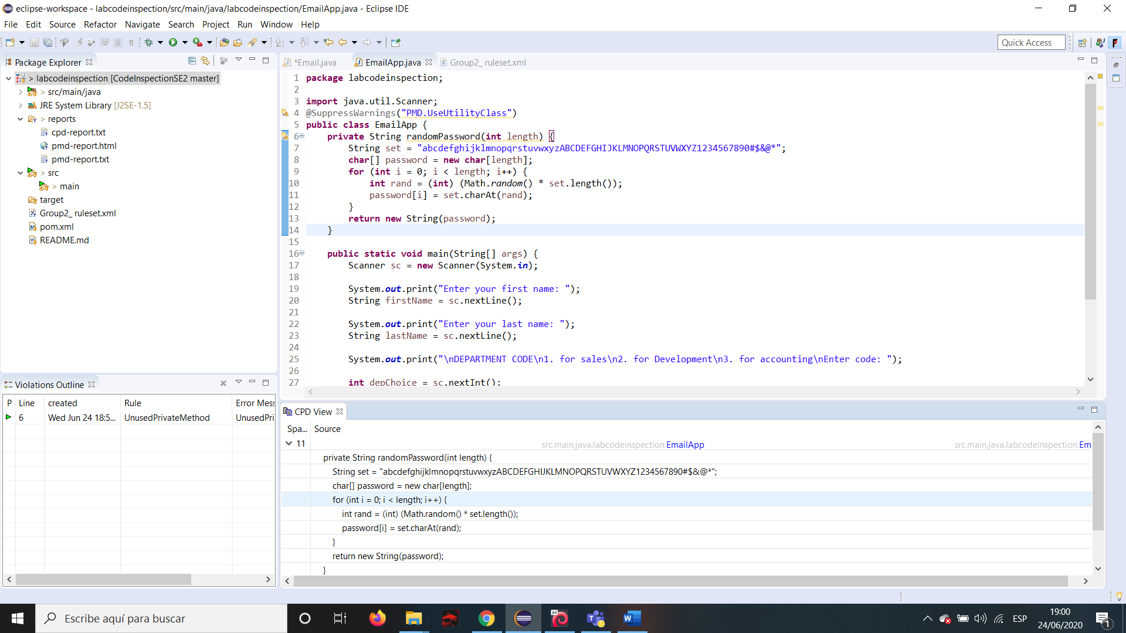

Found a Cut and paste suspect

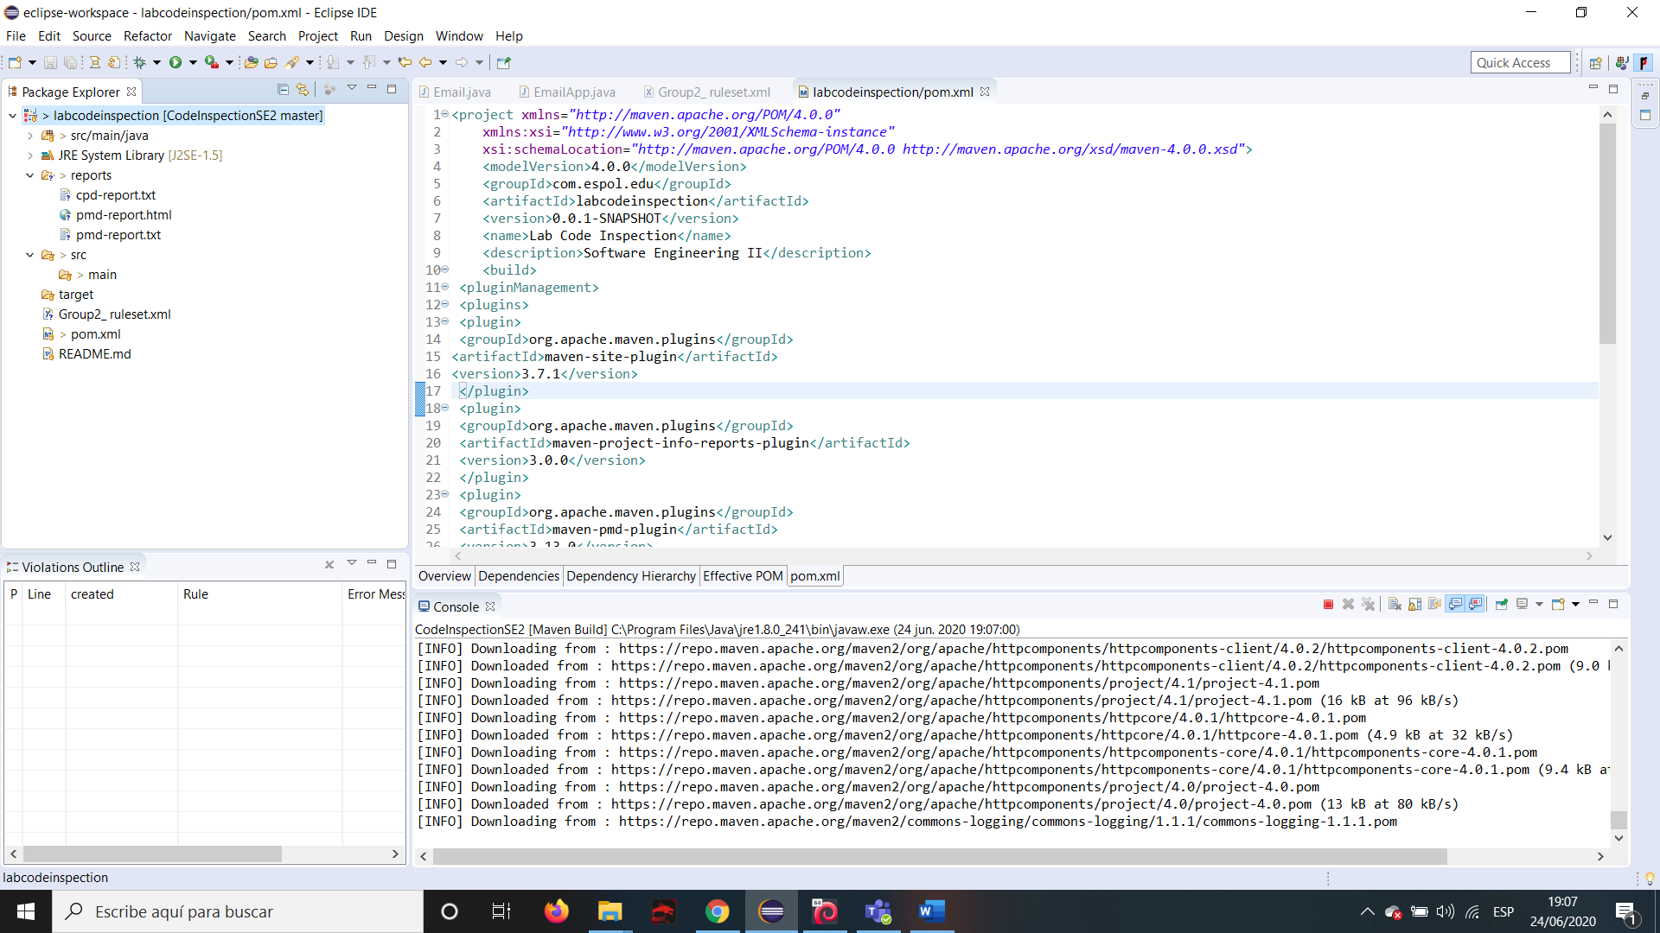

Installing necessary plugins

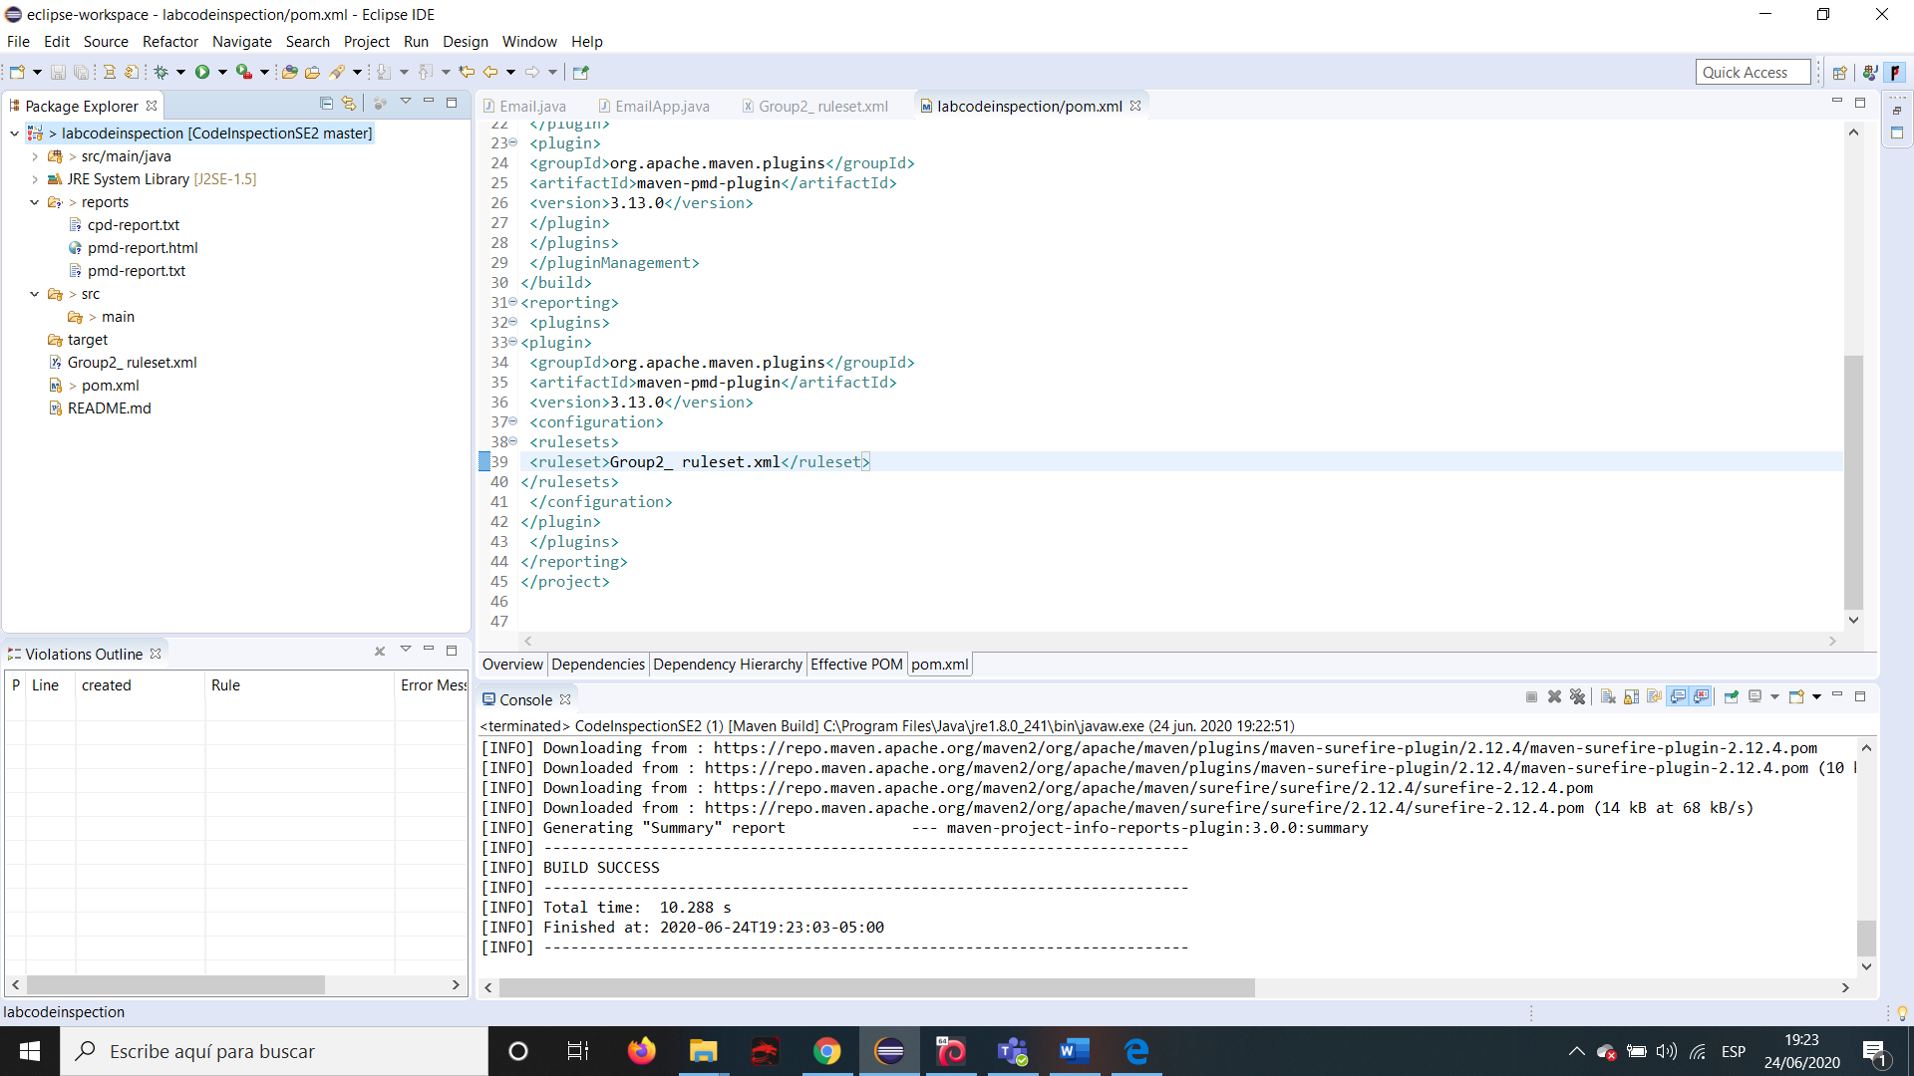

As maven runned

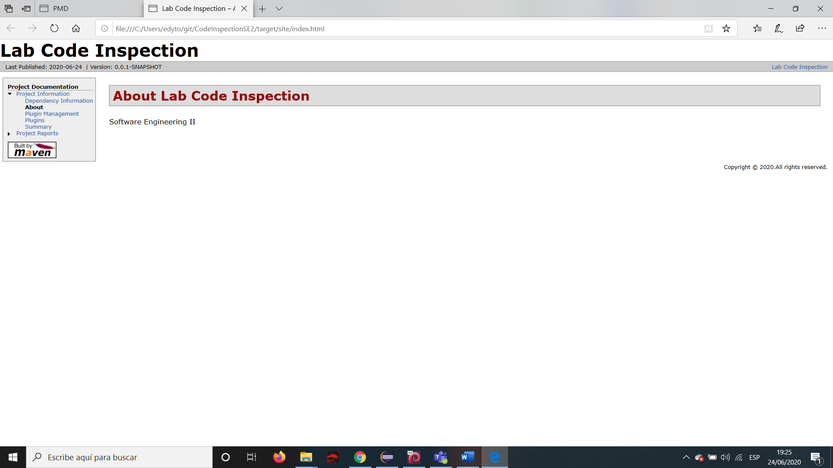

Index.html

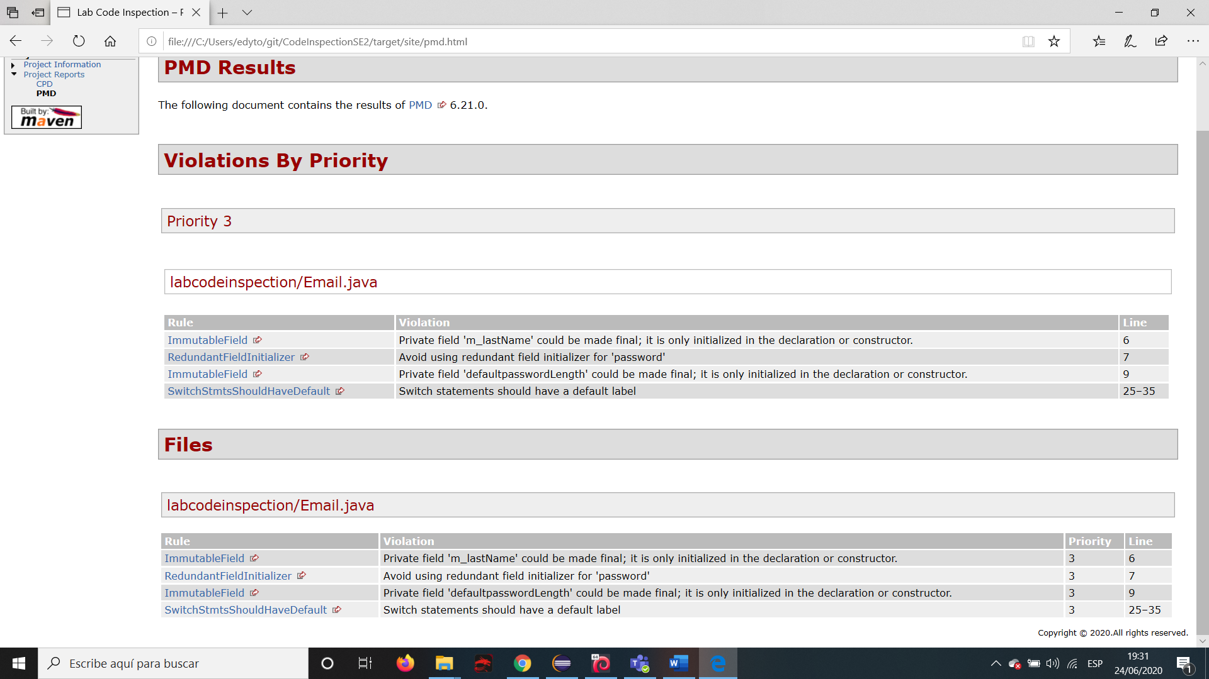

PMD Results

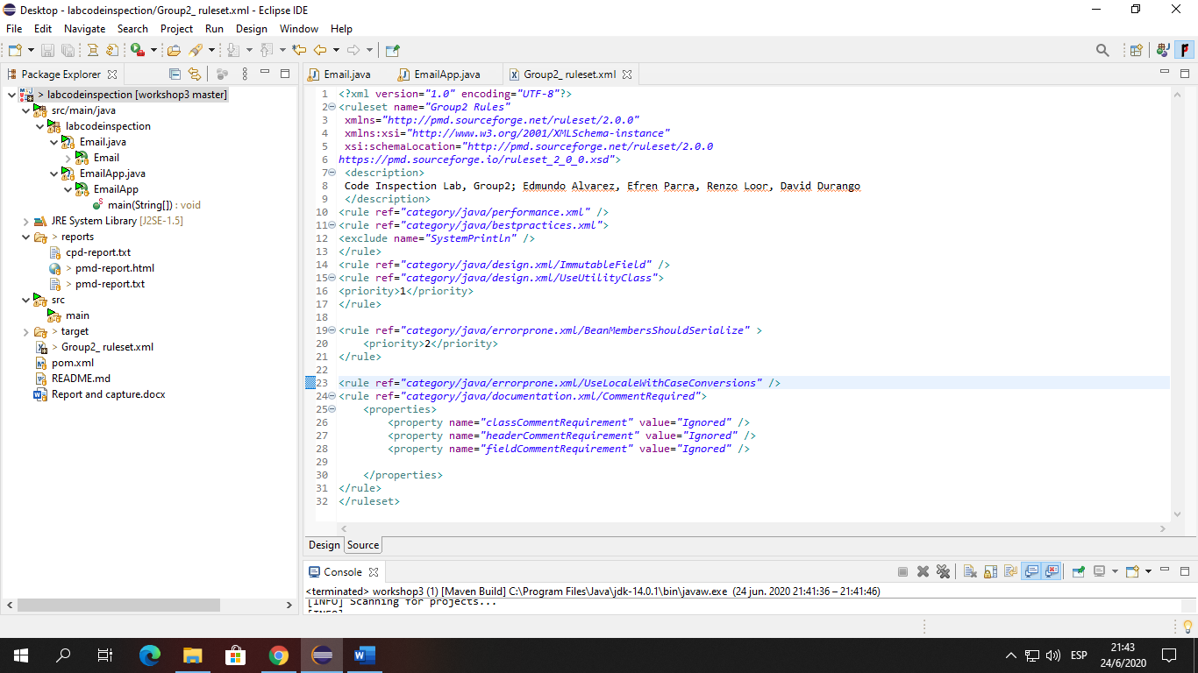

Adding new rules

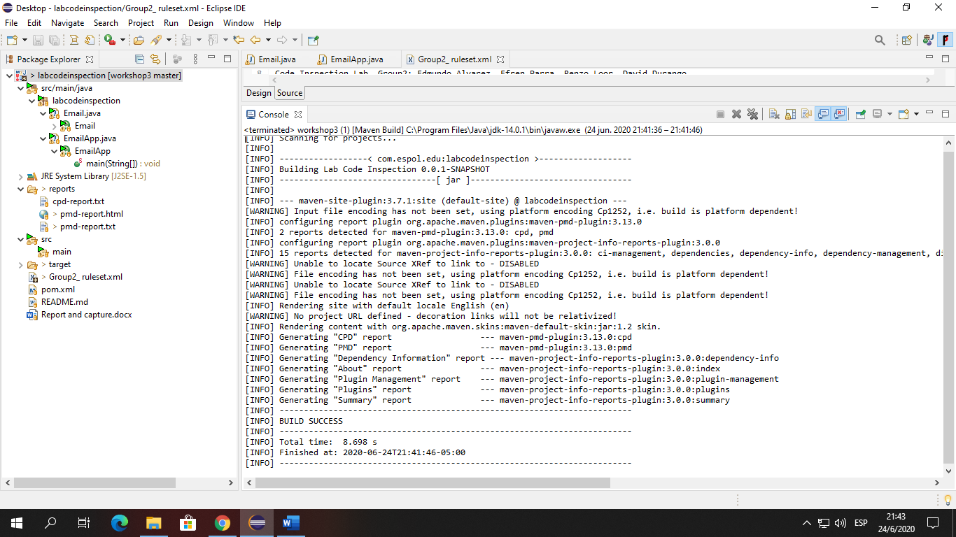

Re-Build project and generate Report

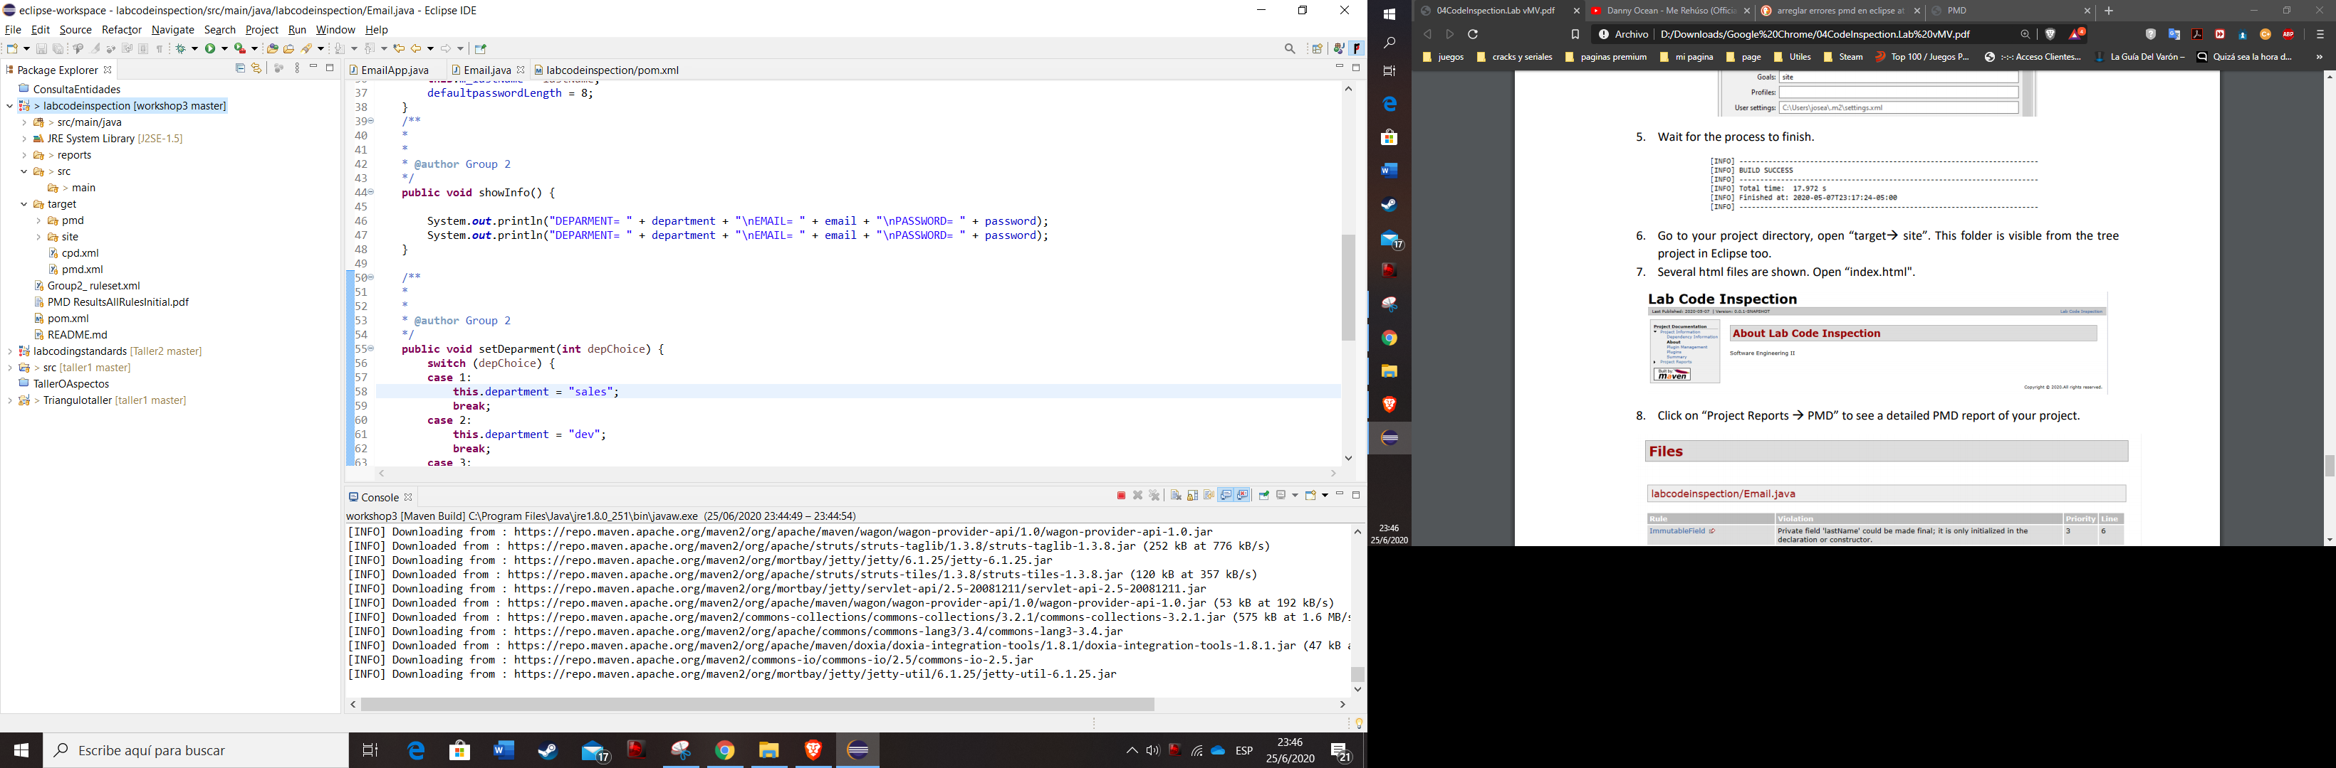

Re-building report without errors

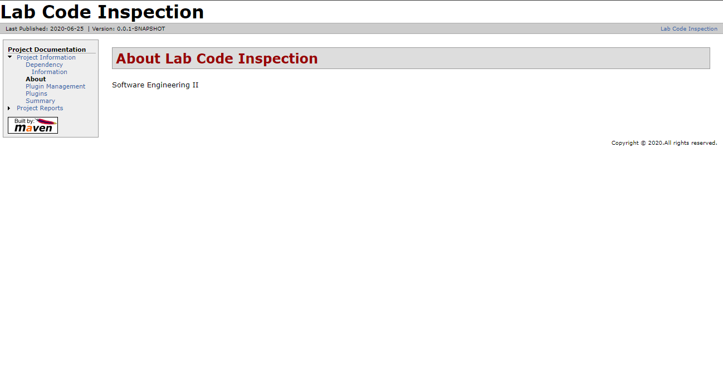

Report without errors